Installationsanleitung
Für die Entwicklung einer Webanwendung mit Symfony Frameworh brauchen Sie folgends :
ein sauberes ubuntu betrieb-system auf ihrem Rechner
Apache2
MySQL
PHP

Schritt 1 :
apache2
sudo apt-get update
sudo apt-get install apache2
sudo service apache2 status
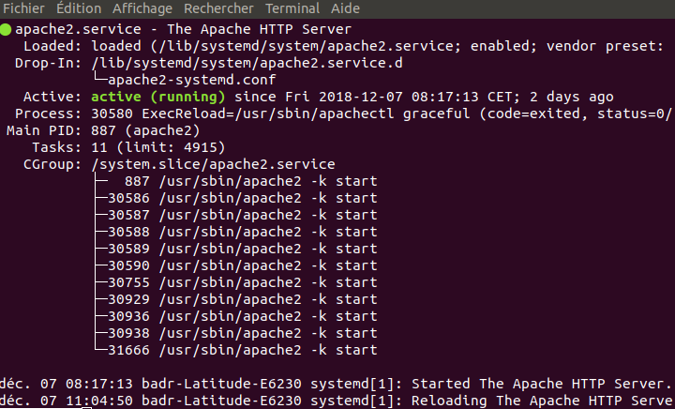
sudo nano /etc/apache2/sites-available/projet-badr.conf
CTRL + v copier le code
<VirtualHost *:80>
ServerName badr-projekt.de
ServerAlias www.badr-projekt.de
DocumentRoot /var/www/projet-badr/public
<Directory /var/www/projet-badr/public>
Order Allow,Deny
AllowOverride All
Allow from all
<IfModule mod_rewrite.c>
Options -MultiViews
RewriteEngine On
RewriteCond %{REQUEST_FILENAME} !-f
RewriteRule ^(.*)$ index.php [QSA,L]
</IfModule>
</Directory>

# uncomment the following lines if you install assets as symlinks
# or run into problems when compiling LESS/Sass/CoffeeScript assets
# <Directory /var/www/project>
# Options FollowSymlinks
# </Directory>

ErrorLog /var/log/apache2/project_error.log
CustomLog /var/log/apache2/project_access.log combined
</VirtualHost>
sudo a2ensite projet-badr
sudo systemctl reload apache2
sudo cat /etc/apache2/sites-available/projet-badr.conf
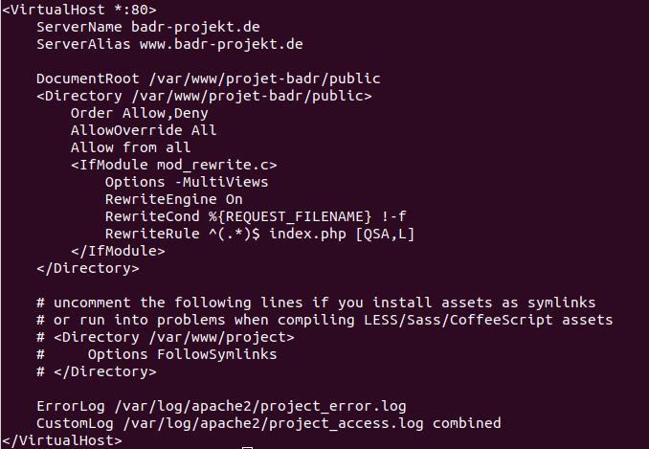
sudo nano /etc/hosts
CTRL + V ADD for fichier
127.0.0.1 badr-projekt.de
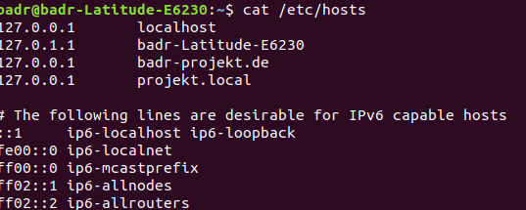
cd /var/www
copier le projet ici
cd /var/www/projet-badr/

INSTALL PHP

apt-get update && apt-get upgrade
sudo apt-get install php
sudo apt install php7.2-cli
sudo apt install hhvm
sudo apt-get install php-pear php-fpm php-dev php-zip php-curl php-xmlrpc php-gd php-mysql php-mbstring php-xml libapache2-mod-php
php7.2-tidy php7.2-dev php-redis re2c
sudo apt install php7.2 libpcre3-dev libfreetype6-dev libjpeg-turbo8 libmcrypt-dev libicu-dev libpq-dev libbz2-dev php-pear libxml2-dev wget libevent-dev php7.2-iconv php7.2-bz2 php7.2-intl php7.2-bcmath php7.2-opcache php7.2-gd php7.2-soap php7.2-opcache php7.2-curl php-xdebug vim nano supervisor
sudo update-alternatives --set php /usr/bin/php7.2
sudo apt install composer
INSTALL COMPOSER
php -r "copy('https://getcomposer.org/installer', 'composer-setup.php');"
php -r "if (hash_file('sha384', 'composer-setup.php') === '93b54496392c062774670ac18b134c3b3a95e5a5e5c8f1a9f115f203b75bf9a129d5daa8ba6a13e2cc8a1da0806388a8') { echo 'Installer verified'; } else { echo 'Installer corrupt'; unlink('composer-setup.php'); } echo PHP_EOL;"
php composer-setup.php
php -r "unlink('composer-setup.php');"
php composer-setup.php – version
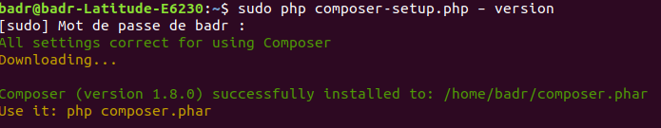
sudo composer require symfony/apache-pack

INSTALL PROJET symfony
composer install

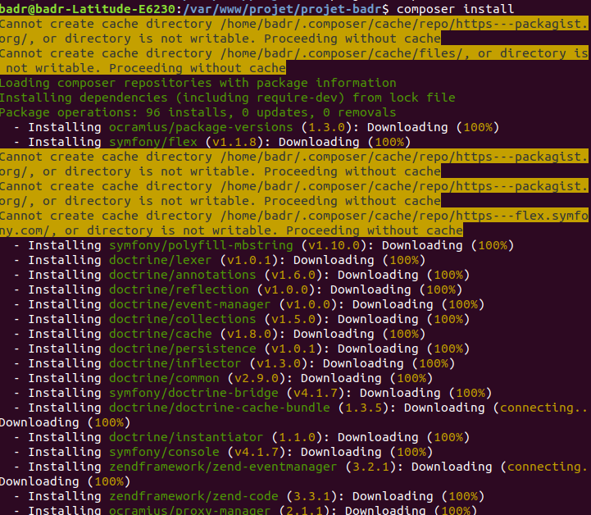
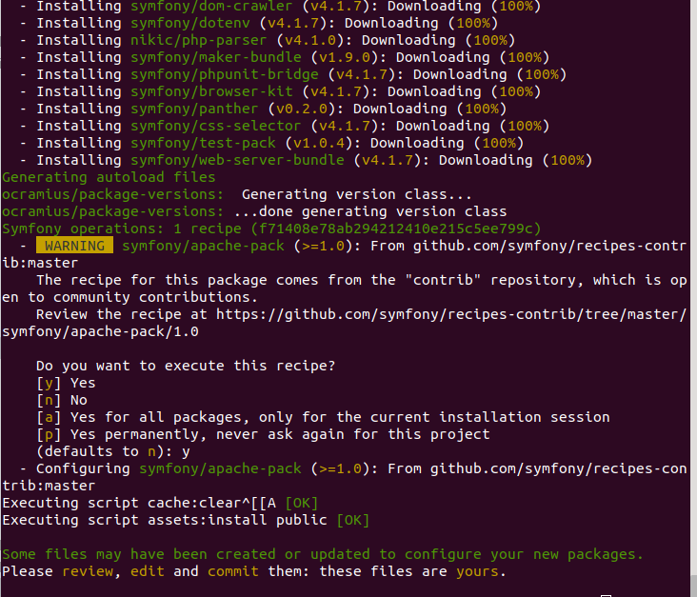
sudo php bin/console make:controller
bin/console debug:router
bin/console debug:php bin/console debug:router –env=prod
php bin/console debug:router –env=prod
sudo rm /etc/apache2/sites-enabled/projet-badr.conf
sudo apt-get install apache2 php mysql-server
sudo php bin/console cache:clear --env=dev && sudo rm -R var/cache/* && sudo rm -R var/log/* && sudo chmod -R 777 var/cache && sudo chmod -R 777 var/log
INSTALL SQL
sudo apt-get update
- sudo apt-get install mysql-server
systemctl status mysql.service
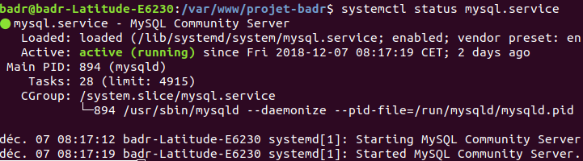

CO NFIG SQL
sudo mysql -u root -proot
CREATE USER 'newuser_badr'@'localhost' IDENTIFIED WITH mysql_native_password BY 'password';
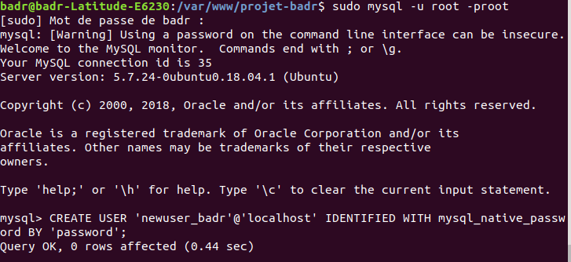
GRANT ALL PRIVILEGES ON *.* TO 'newuser_badr'@'localhost';
FLUSH PRIVILEGES;
exit;
sudo systemctl restart mysql
mysql -u newuser_badr -ppassword
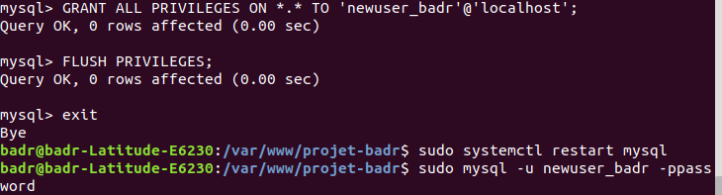
$ mysql> CREATE DATABASE projekt_badr;
$ mysql> exit;

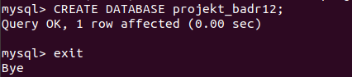

CONFIG SQL FOR SYMFONY

sudo composer require symfony/orm-pack
sudo composer require symfony/maker-bundle –dev
php bin/console make:migration
php bin/console doctrine:migrations:migrate
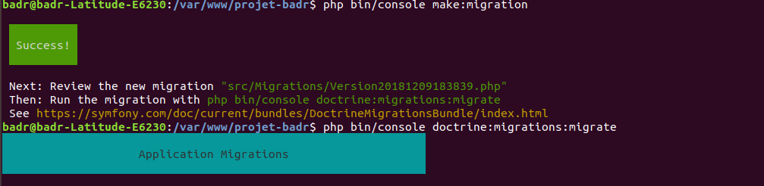
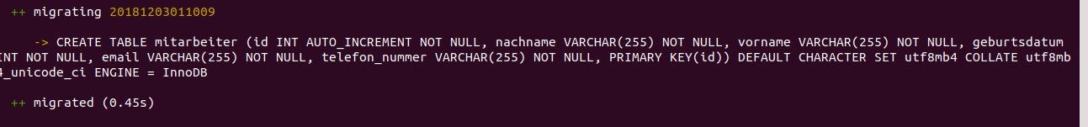

BOOTSTRAP

sudo apt install npm
npm install bootstrap
bin/console assets:install
composer require twbs/bootstrap:4.1.3
sudo composer require twbs/bootstrap:4.1.3
bin/console assets:install

